**Red Black Tree Practice Problems**

**Insert 2, 1, 4, 5, 9, 3, 6, 7**

Below is a trace of inserting the following values into an initially empty red/black tree...

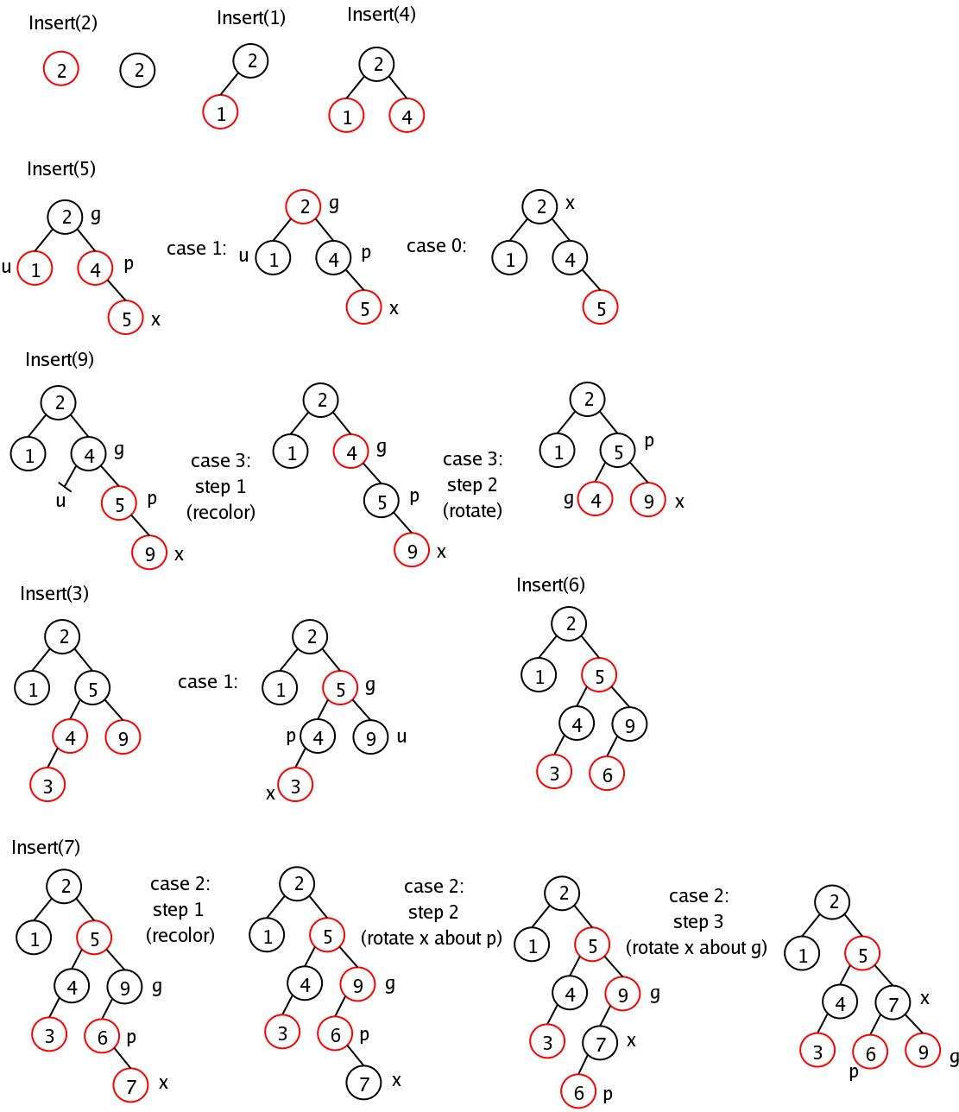

**Remove 90, 80, 70**